Create 1vm

Configuration- HDD (SCSI)-20GB (Boot Disk) , HDD(SCSI)-1GB, HDD(SCSI)-1GB Adapter-NAT

Raid 0

#ip a ….(check for ip )

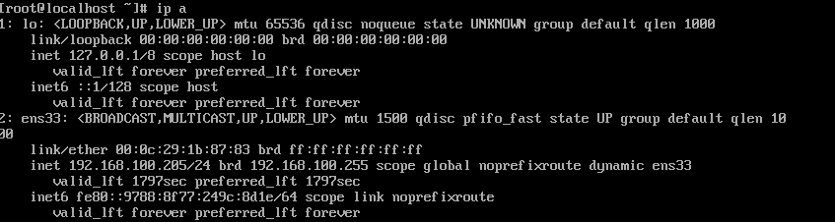

#lsblk

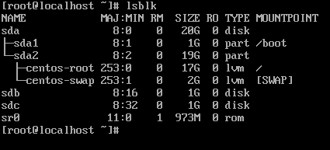

#yum clean all

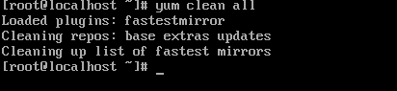

#yum update –y



#yum install mdadm –y

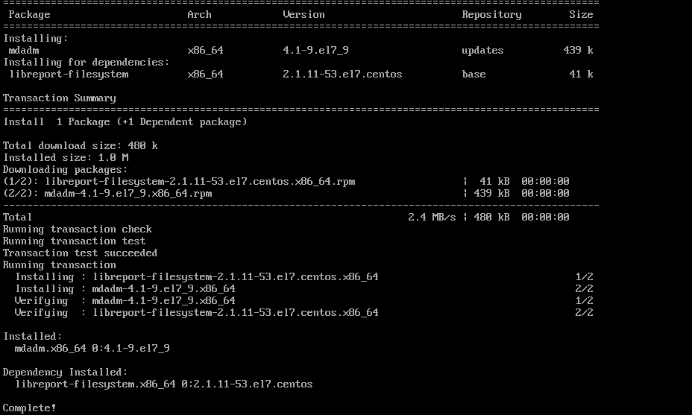

#fdisk /dev/md0

Press n

Press p

Enter enter 2 times

Press w

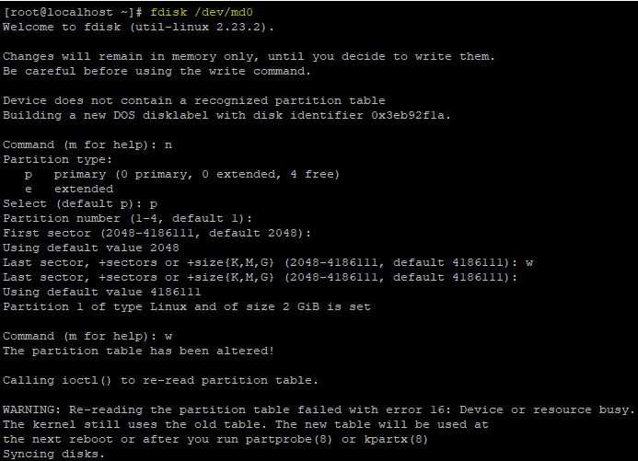

#lsblk

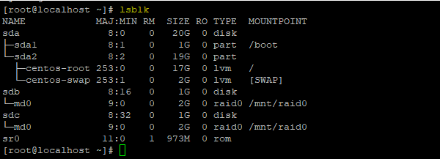

#fdisk –l

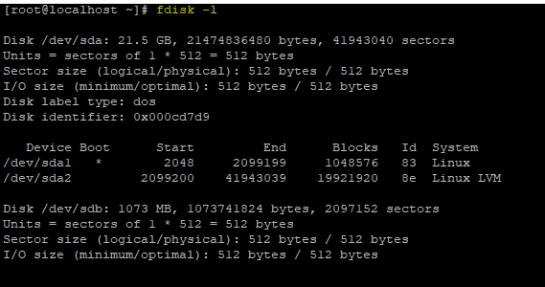

#mkfs.ext4 /dev/md0



#mkdir /mnt/raid0



#mount /dev/md0p1 /mnt/raid0/



#df –Th

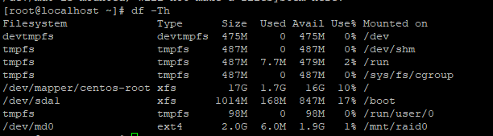

#cd /mnt/raid0/

#ls

#touch test

# dd if=/dev/zero of=500mb.file bs=1024 count=502400

